* **How To Connect Postgres to Power bi:**

1) In Server, write Local Host.

2) In Database, write Database name.

3) In Username, write Postgres.

4) In Password, write the password.

* **Problem Statement for KPI’s:**

1. Total Revenue

- The Sum of the total price of all pizza orders.

SELECT CAST(SUM(total_price) AS DECIMAL(10,2)) AS total_revenue FROM pizza_sales;

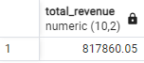

1. Average Order value

- The Average amount spent per order.

- Calculated by dividing the total revenue by the total no. of order.

SELECT CAST(SUM(total_price) / COUNT(DISTINCT order_id) AS DECIMAL(10,2)) AS average_order_value FROM pizza_sales;

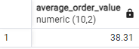

1. Total Pizzas Sold

- The sum of the quantities of all pizzas sold.

SELECT SUM(quantity) AS total_pizza_sold FROM pizza_sales;



1. Total orders

- The total number of orders placed.

SELECT COUNT(DISTINCT order_id) AS total_orders FROM pizza_sales;

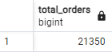

1. Average Pizza Per Order

- The average number of pizzas sold per order.

- Calculated by dividing the total number of pizzas sold by the total number order.

SELECT CAST(CAST(SUM(quantity) AS DECIMAL(10,2)) /

CAST(COUNT(DISTINCT order_id) AS DECIMAL(10,2)) AS DECIMAL(10,2)) AS average_pizzas_per_order FROM pizza_sales;

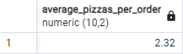

* **Problem Statement for Chart Requirement:**

1. Daily Trends For total orders

* Bar chart That displays trends of Total orders over a specific time period. This chart will help us identify any pattern or fluctuations in order volumes on daily basis.

SELECT TO_CHAR(order_date, 'Day') AS order_day, COUNT(DISTINCT order_id) AS total_orders

FROM pizza_sales

GROUP BY TO_CHAR(order_date, 'Day');

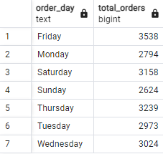

1. Monthly Trend of the Total orders

* Bar chart that illustrates the monthly trend of total orders over a specific time period. This chart will allow us to identify the peak month of order activity.

SELECT TO_CHAR(order_date, 'Month') AS month_name, COUNT(DISTINCT order_id) AS total_orders

FROM pizza_sales

GROUP BY TO_CHAR(order_date, 'Month');

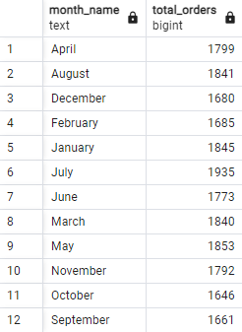

1. Percentage of sales by Pizza Category

* Pie chart that shows the distribution of sales across different Pizza categories. This chart will provide insights into the popularity of various pizzas categories and their contribution to overall sales.

SELECT pizza_category, CAST(SUM(total_price) AS DECIMAL(10,2)) AS total_sales, CAST(SUM(total_price) * 100 / (SELECT SUM(total_price) FROM pizza_sales) AS DECIMAL(10,2)) AS percentage_of_total_sales

FROM pizza_sales

GROUP BY pizza_category;

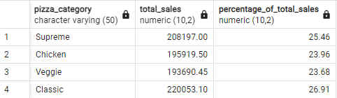

1. Percentage of sales by pizza size

* Pie chart that represents the percentage of sales attributed to different pizza sizes. This chart will help us understand customer preferences for pizza sizes and their impact on sales.

SELECT pizza_size, CAST(SUM(total_price) AS DECIMAL(10,2)) AS total_sales, CAST(SUM(total_price) * 100 / (SELECT SUM(total_price) FROM pizza_sales) AS DECIMAL(10,2)) AS percentage_of_total_sales

FROM pizza_sales

GROUP BY pizza_size;

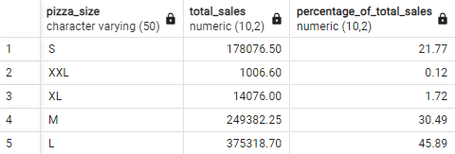

1. Total Pizzas sold by Pizza category

* Funnel Chart that presents the total no. of pizzas sold for each pizza category.

SELECT pizza_category, SUM(quantity) AS total_pizza_sold

FROM pizza_sales

GROUP BY pizza_category;

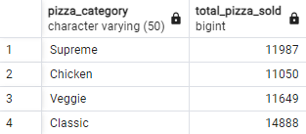

1. Top 5 best sellers by revenue, Total Quantity and Total orders

* Bar chart highlighting the top 5 best-selling pizzas based on the revenue, total quantity , total orders. This chart helps us identify the most popular pizza options.

SELECT pizza_name, CAST(SUM(total_price) AS DECIMAL(10,2)) AS total_revenue

FROM pizza_sales

GROUP BY pizza_name

ORDER BY total_revenue DESC

LIMIT 5;

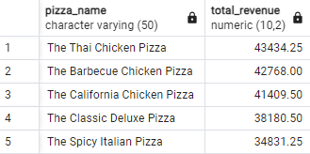

SELECT pizza_name, CAST(SUM(quantity) AS DECIMAL(10,2)) AS total_quantity

FROM pizza_sales

GROUP BY pizza_name

ORDER BY total_quantity DESC

LIMIT 5;

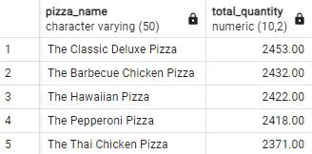

SELECT pizza_name, CAST(COUNT(DISTINCT order_id) AS DECIMAL(10,2)) AS total_orders

FROM pizza_sales

GROUP BY pizza_name

ORDER BY total_orders DESC

LIMIT 5;

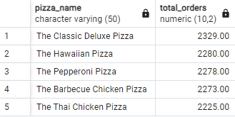

1. Bottom 5 worst seller by Revenue, total quantity and total orders

* Bar chart showcasing the bottom 5 worst-selling pizzas based on the revenue, total quantity, total orders. This chart will enable us to identify underperforming or less popular pizza options.

SELECT pizza_name, CAST(SUM(total_price) AS DECIMAL(10,2)) AS total_revenue

FROM pizza_sales

GROUP BY pizza_name

ORDER BY total_revenue

LIMIT 5;

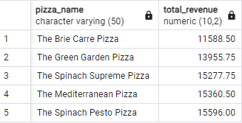

SELECT pizza_name, CAST(SUM(quantity) AS DECIMAL(10,2)) AS total_quantity

FROM pizza_sales

GROUP BY pizza_name

ORDER BY total_quantity

LIMIT 5;

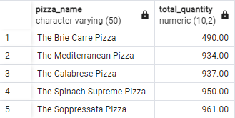

SELECT pizza_name, CAST(COUNT(DISTINCT order_id) AS DECIMAL(10,2)) AS total_orders

FROM pizza_sales

GROUP BY pizza_name

ORDER BY total_orders

LIMIT 5;

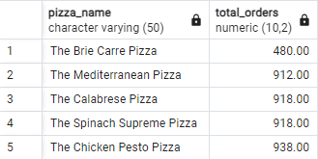

* **Data Preprocessing in power bi:**

1. We need days of week separately but the data which is available in the table are in the format of DD/MM/YYYY.
2. So we create a new column of days of the week only using the power query.
3. Now we get a new column of days of the week but we only want starting three alphabets of the days. For eg: Friday-> fri, Sunday-> sun.
4. To do that we create a new column using day functions.

Order Day= UPPER (LEFT (Pizza sales [Day Name], 3))

* Day name is the new column we created above.

1. We create a new column called Day number, if it can be done in a power query using a conditional column in the add column tab.
2. The purpose of doing this because the order of the days are not in sequence, its mix. By using the column day number, we specify the order of the day. Eg Sunday is assigned with 1, like this Saturday is assigned with 7.
3. After creating the day number column, now we need to implement it.
4. Select order day column, and in columns tool, select day number in sort by column option.
5. Now we’ll do the same for a month also.
6. In power query, in add column tab, using date to create a new column called month name for sorting purpose.
7. Using the same procedure from Days of the week, we make a new column of first 3 alphabets of the month name.